Name: ________________________ **Please return to school on Monday
Math Practice #12
Weekly focus…
- This week we are working on concepts related to geometry and spatial sense, such as:
  - Identifying and describing 2-D and 3-D shapes
  - Sorting and classifying shapes according to their attributes
  - Try http://www.ixl.com/math/grade-1 (activities J.1-J.12) for more practice!

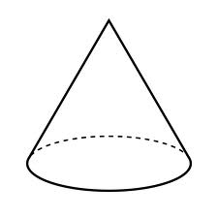
Monday *Count the shapes and write the number on the line.

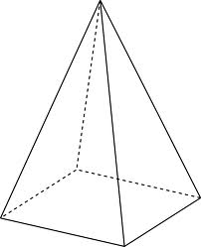

How many cylinders are there? ________________________
How many pyramids are there? ________________________
How many cones are there? _______________________
How many spheres are there? _________________________
How many cubes are there? ______________________

Tuesday *Fill in the blanks.

1. A _______________________ is round.

2. A rectangular prism has ________________ corners.

3. A ______________________ has 6 square faces.

4. A ______________________ has 1 circle face.
Wednesday *Fill in the blank with the correct shape. Use the word bank for help.

WORD BANK: cone cube sphere cylinder pyramid rectangular prism

Thursday *Where do you see these shapes in your home? Follow the example.

Shape | In my home
sphere

rectangular prism

cube

cylinder

Friday *Learn about shapes on your computer!
http://www.ixl.com/math/grade-1 (Activity J)
http://www.abcya.com/shapes_geometry_game.htm

