Name: _______________________ **Please return to school on Monday
Word Study #22
Word Study Words
1. Sunday 5. Thursday
2. Monday 6. Friday
3. Tuesday 7. Saturday
4. Wednesday

Monday *Read the list of words, and write each word 3 times.

- _______________________________________________________
- _______________________________________________________
- _______________________________________________________
- _______________________________________________________
- _______________________________________________________
- _______________________________________________________
- _______________________________________________________
Tuesday *Fill in the blanks with the correct word.
1. Today is _________________. Tomorrow will be Tuesday.
2. Today is Wednesday. Tomorrow will be _________________.
3. We don’t go to school on ________________ and _______________ because
it is the weekend.
4. The day after Thursday is _________________.
5. The day before Wednesday is _________________.
6. Today is Tuesday. We have library and swimming tomorrow on
_________________.

Wednesday *Calendar questions!
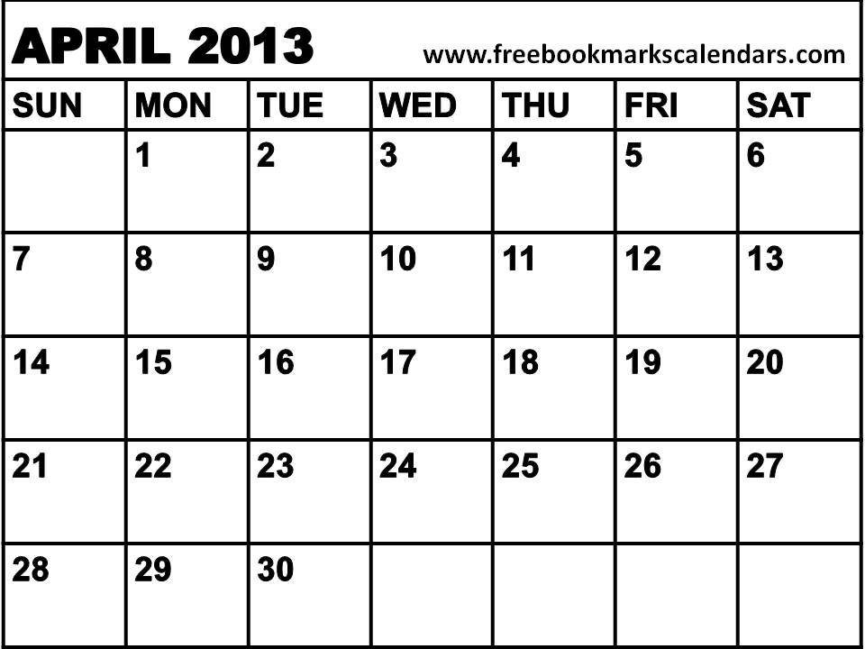
Example:
Which day is April 5th? Friday
How many Sundays are there in April? four

1. Which day is April 28th? _______________
2. Which day is April 10th? ______________
3. Which day is April 19th? ______
4. How many Thursdays are there in April? ______
5. How many Mondays are there in April? ______
6. Which day will May 1st be? _______________

Thursday *Choose 5 word study words and make a sentence. Don’t forget to underline the word you used. Ex: (cat) I have a cat.
1.
2.
3.
4.
5.

Friday *Find the hidden words.
E A M F R I D A Y
F E T U E S D A Y
L E H S U N D A Y
N L U E E S D A C
M A R Y E R D T A Sunday, Monday, Tuesday,
Z K S N U N E Z R Wednesday, Thursday,
M T D T O I O U R Friday, Saturday
N E A M B G L N I
W S Y M M R V R U
Great work! Your word study is finished. Don’t forget to bring your Word Study homework to school next week! The Word Study spelling test #22 will be on Monday.

